Analysis of the potential impact of areas with soil contamination on watercourses and wells in São Paulo
ABSTRACT
The aim of this paper is to identify water bodies and wells at risk related to the proximity of contaminated soil areas in the city of São Paulo. Safety circles were traced between the contaminated areas and the potential contamination targets according to the hydrogeological characteristics of the aquifers. Thus, it was possible to determine intersections with rivers and wells, mapping them as under risk of contamination. A map of the accumulated impact of pollution on the hydrography was produced, according to the hydrological topology, taking into consideration the potential upstream contamination points. The groundwater vulnerability to contamination was also mapped, through an Aquifer Vulnerability Index (AVI) that takes into account the hydraulic conductivity and the unsaturated depth of the aquifer. Forty-nine wells (1.68%), of which 65.31% are categorized for human drinking supply, have a potential risk of contamination. These are located predominantly in areas of high population density and extremely high vulnerability to aquifer contamination. The results contributed to the analysis of water resources in São Paulo, in order that users and public authorities could be made aware of the risks of contamination and could prioritize preventive measures regarding these risks.

Keywords: Contaminated areas, groundwater, pollution, hydrogeology, water resources.
INTRODUCTION
Since the middle of the twentieth century, the concern about the impacts of human actions on the environment has increased. The acceleration of scientific and technological development, urbanization, and high population density has led to increasing health problems from negative effects of environmental degradation. As a result, a greater interdependence between health and environmental factors has become increasingly evident, especially regarding collective health (BRILHANTE and CALDAS, 1999).
In this context, many pollutants resulting from human activity have been discarded in the soil for generations and can seriously impact on human health. The main pollutants come from urban, industrial, and agricultural uses. The most common sources of pollution and contamination can be classified into six categories, which are (CETESB, GTZ, 2001, FETTER, 1993):
• Sources designed to discharge substances underground, such as septic tanks;
• Sources designed to store, treat and / or dispose of substances in the soil, including waste disposal areas;
• Sources designed to transport substances, such as pipelines, sewage systems and industrial effluent systems;
• Sources used to discharge substances as a result of planned activities, for example agricultural activities (irrigation, fertigation, application of pesticides, and fertilizers) and percolation of air pollutants;
• Sources that act as a preferential way for contaminants to enter an aquifer, such as oil production wells and monitoring wells with design and/or construction failures;
• Natural sources or natural phenomena associated with human activities.
The Municipality of São Paulo has, throughout its history of land occupation, more than 11,000 cases of soil contamination, due to effluents from installed industries, leaks from gas stations, and environmental accidents (HABERMANN and GOUVEIA, 2014). Soil contamination at a specific point in the urban area can extend through the underground aquifer and reach water bodies, causing harmful effects to human health. The main contaminants in these areas are halogenated solvents (in particular aromatic solvents), metals, petroleum hydrocarbons, polycyclic aromatic hydrocarbons, and automotive fuels (Santos et al., 2008). According to CETESB (2020), many of these contaminants are classified as carcinogenic, probable, or possible carcinogens by the International Agency for Research on Cancer (IARC), and even those that are not classified regarding carcinogenicity can still cause respiratory and cardiovascular diseases, decreased fertility, increased spontaneous abortions, and adverse impact on the fetus. They can also impact on development such as decreased birth weight, cognitive ability, attention problems, anxiety, and depression.
There are several factors that influence the underground transport of a pollutant. This transport takes place through the flow in which the pollutant is dissolved, therefore its solubility is important because if the pollutant is inert, the transport will have the average speed of the solvent, in the direction of its flow lines (DYMINSKI, 2006). Other characteristics of the contaminant involved in transport are its density and concentration. In this regard, soil decontamination techniques that increase the solubility of contaminants can increase the speed and magnitude of aquifer contamination.
Another factor that influences the transport of pollutants is the soil, through the processes of physical-chemical adsorption and biochemical degradation of percolating compounds (SOUZA, 2009). The soil retains the contaminant, decreasing the speed of the contamination plume. This phenomenon is called contamination front delay and depends especially on soil’s granulometry, clay fraction mineralogy, permeability, and amount of organic matter (DYMINSKI, 2006). During the soil retention period, other processes such as biodegradation, volatilization, and radioactive decay can gradually decrease the potential for contamination.
Specifically regarding the contamination of aquifers, hydrogeological factors (such as aquifer recharge potential, hydraulic conductivity of the medium, the hydraulic gradient, porosity, and also the depth of the water level) significantly influence the displacement of the pollutants (GUIGUER, KOHNKE, 2002). After reaching the phreatic level, the plume of pollution will then be carried to other regions through the flow of these waters and may reach wells and other abstractions of groundwater, due to the existing intersections with the aquifers (SOUZA, 2009). Once polluted or contaminated, groundwater demands a high expenditure of financial resources for its remediation (ANA, 2007).
The Environmental Company of the State of São Paulo—CETESB—maintains an annually updated database of registered contaminated areas published on its portal (CETESB, 2019). Considering the diversity of interference factors needed to analyze and determine which wells and water bodies are at risk of contamination, a simplified approach to preliminary risk analysis is the delimitation of circular prevention perimeters. The circular prevention perimeter is based on the alert perimeter established in São Paulo State Decree No.32.955, of 1991. According to Art. 25 of this decree: “In each case, in addition to the Immediate Health Protection Perimeter, Pollution Alert Perimeters will be established, based on a coaxial distance to the flow direction, from the point of capture, equivalent to the transit time of fifty days of water in the aquifer, in the case of non-conservative pollutants”.
This study aims to determine which contaminated areas should be prioritized for remediation by analyzing the potential impact of soil contamination on wells and water bodies in the Municipality of São Paulo. In this approach, it defines the risk based on the circular protection perimeter, which was determined from the interpolation of the stabilization flow by indicative kriging, in addition to mapping the accumulation of the risk of pollution on the hydrography. The vulnerability to the contamination of groundwater in the Municipality of São Paulo was considered in the analysis, using the AVI method, where the two parameters (static flow and hydraulic conductivity) were interpolated by ordinary kriging, finally comparing it to the population's exposure to contamination.

METHODOLOGY
Characterization of the study area
The study area comprises the Municipality of São Paulo, which in 2017 represented 36% of the contaminated and rehabilitated areas in the State of São Paulo (CETESB, 2017). It is located in the southeast of the State of São Paulo and has thirty-two subprefectures (Figure 1). According to IBGE (2019), it has an area of 1,521,110km² (2018) and an estimated population of 12.2 million inhabitants in 2019.
The rocks of the São Paulo sedimentary aquifer, above which the respective municipality is located, belong to the following lithological units: (1) Taubaté group (Paleogene) constituted, from the bottom to the top, by the following formations: Resende (sandstones, conglomerates, diamictites and lamites), Tremembé (clay, shale, marl and dolomitic limestone) and São Paulo (sandstone, clay, siltstone and conglomeratic sandstone); (2) Itaquaquecetuba Formation (arkose, coarse sandstones, rocks and fault breccias) (Neogen); and (3) alluvial and colluvial coverings (Quaternary) (RICCOMINI & COIMBRA 1992). According to Rocha et al. (2006), the average thickness of the aquifer is 100m, and in some areas, it can reach more than 250m depth. Below the São Paulo aquifer are lithologies of fractured rocks of the Precambrian crystalline basement (PACHECO, 1984).
Figure 1: Location of the study area: Municipality of São Paulo and subprefectures
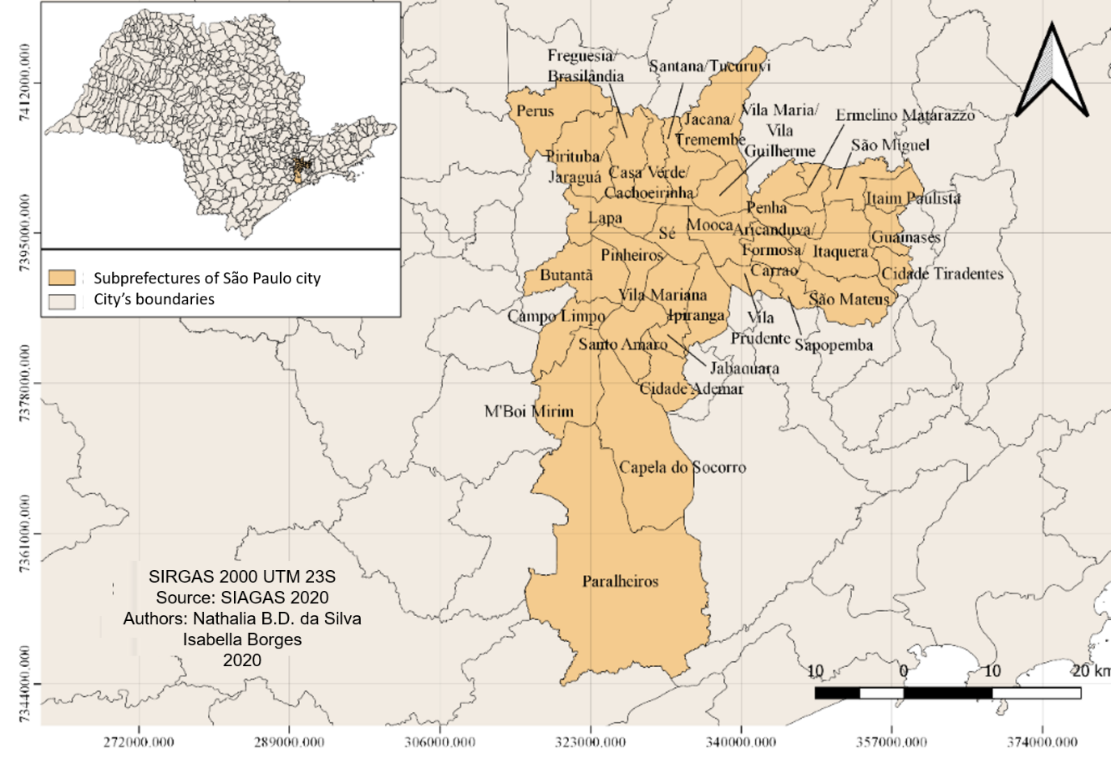
Source: the authors (2020).
Databases
This study was developed with the CETESB database, concerning points of soil contamination. The Secretariat of Green and Environment of the Municipality of São Paulo compiles this data for the municipality and makes the georeferenced file openly available. The same secretariat also provides the hydrography spatial database for the municipality, as well as the administrative limits of the Municipality and the State of São Paulo. The location and characteristics of the water wells were obtained using the SIAGAS system, maintained by the Brazilian Geological Service (CPRM) .
In order to analyze the population's exposure to the risk of contamination, a population density map was generated using the 2010 census data from IBGE, available through the Statistical Grid (IBGE, 2016).

Structural analysis of geographical data
The spatial correlation structure of well data in the SIAGAS system was analyzed using semivariograms. Through the semivariogram, a geostatistical estimator of the spatial dependence of the data, we found the optimal weights used to interpolate the values associated with the existing samples through kriging interpolation. The experimental semivariogram of each variable was determined based on each value of h (distance between pairs of points) considering all pairs of samples z(x) and z(x + h), separated by the distance vector h, from Equation 1 (CAMARGO et al., 2004):
(Equation 1)
Where:
is the estimated semivariogram
is the number of measured values of pairs.
The versus h graph indicates how the samples correlate. The parameters observed in the semivariogram and used to perform the kriging were (CAMARGO, 1998): the range, which is the distance within which the samples are spatially correlated, and which corresponds visually to the value at which the semivariogram stabilizes; the sill, which is the value of the vertical axis of the semivariogram corresponding to its range; and the nugget effect, which in turn is the value of the semi-variance when the distance tends to zero and represents the residual and random variation.

Data interpolation
The spatial interpolation was performed in order to estimate values of variables of interest where there is no information. There are several interpolation models, of which we chose the kriging methods, as they take into account the spatial correlation structure of spatial data through semivariograms, calibrated by cross-validation, thus allowing greater reliability (OLIVER and WEBSTER, 2015). Kriging incorporates spatial variation in interpolation, with the objective of generating a non-biased estimation surface, accompanied by an auxiliary standard deviation surface that informs the predictive uncertainty in each mapped location (YAMAMOTO and LANDIM, 2013). In addition, due to the great spatial variation of groundwater data, kriging stands out for being a non-deterministic method, which, by modeling the ideal nugget effect magnitude, creates a smoothed interpolation surface with better prediction capacity (MONTÉS, 1994). Kriging has been widely used in the interpolation of groundwater data, with satisfactory results, when compared to other methods (GUNDOGDU and GUNEY, 2007; AHMADI and SEGHAMIZ; 2008; MOSLEMZADEH et al., 2011; VASCONCELOS et al., 2017).
There are several kriging methods, one being ordinary kriging which was used in the present article. Ordinary kriging seeks optimal predictions of the variable under study, in unobserved locations, minimizing the variance of the error associated with this estimate. The other method used in the present article is indicative kriging, which indicates the probability of a variable, at each mapped location, to exceed a specified threshold (FELGUEIRAS et al., 2004).

Results validation
Cross-validation was used to assess how well the statistical models of interpolation were appropriate for the studied phenomena, i.e., whether the models predict unknown values with greater or lesser precision. In spatial interpolation techniques, cross-validation sequentially omits a point and predicts its value using the remaining data, then compares the predicted and sampled values. This analysis is repeated by removing each of the sampled points. In the end, the errors obtained at each point are evaluated together, building indicators of predictive quality.
Several statistical indicators were used to assess the model's performance. To provide better accurate predictions, interpolation models were sought with the mean error close to zero, the root mean squared error value and the mean predicted standard error being as small as possible and the standardized root mean squared error value close to 1 (JOHNSTON et al., 2001).

Delimitation of the diameter of the protection perimeter
Instituto Geológico (2010) proposed safety circular perimeters to protect water sources from underground contaminants in the State of São Paulo. In the present study, these perimeters were delimited departing from the contaminated soil areas in the city of São Paulo, to mark where they intersect with wells and rivers in the city. The radius adopted was 30m to 50m depending on the yield of the wells, as proposed by Instituto Geológico (2010) for the São Paulo sedimentary aquifer, in which the Municipality of São Paulo is located, following the specifications of State Decree No. 32,955, of 1991, which establishes the perimeters of protection. The flow of up to 20m³/h requires a radius of 30m, while the flow above 20m³/h requires a radius of 50m.
For the stabilization yield data used to determine the safety radius, the semivariogram was processed by the Geoestatiscal Analyst extension of the ArcGis 10.6 software, and its parameters were automatically calibrated, with subsequent visual assessment of the semivariogram and manual iteration of the maximum and minimum values of neighbors. Also the neighborhood sectors were switched until achieving the best semivariogram with the lowest value of the root of the mean squared error obtained by cross-validation.
Based on the semivariogram, spatial interpolation was performed by indicative kriging of the stabilization yield data from the wells in the study region using the same extension of the ArcGis 10.6 software. This indicative kriging tells us which areas in the municipality are most likely to contain wells with a yield rate above 20m³/h. The final interpolated raster was reclassified based on Equation 2:

R=30+(prob*20) (Equation 2)
where:
R is the radius
prob is the probability that the yield of the well will be above 20m³/h.
When prob equals zero, the flow is less than or equal to 20m³/h and therefore the established radius is 30m; when prob is equal to one, the flow rate is certainly greater than 20m³/h and the established radius is 50m. At intermediate values of prob (between 0 and 1), the radius gradually increases from 30m to 50m. This is an improvement of the methodology proposed by the Geological Institute (2010), since it creates a gradation of the radius based on the evaluation of the uncertainty regarding the yield of the wells. Thus, it was established what the minimum safety distance for each contaminated area would be, also creating a circular buffer with a radius of 30m to 50m depending on the previous classification.
Therefore, it was first necessary to transfer the value found in the kriging of the yield data to the point base of the contaminated areas. In this case, the Complement Point Sampling Tool was used in QGIS. Once this was done, analysis determined how likely it would be for a well yield to be above 20m³/h at the central point of each contaminated area. The safety radius of each of these areas was determined using Equation 2, adding this radius to the attributes table of the point base of contaminated areas. The radius buffer was then created, being equal to the value obtained by the respective equation.
Based on those previous steps, maps were created to visualize the contaminated points that intersect water bodies and wells, characterizing them as being at risk of contamination. For the hydrographic network, the potential accumulation of pollution on the hydrography was mapped, topologically connecting the stretches of rivers according to the number of potentially contaminating areas upstream.

Vulnerability Index
The vulnerability of groundwater to soil contamination was calculated using the AVI (Van Stempvoort et al., 1992) using the R software. This method is based on two physical parameters: thickness of the sedimentary layer above the surficial saturated zone, and hydraulic conductivity.
The parameter related to the thickness of the sedimentary layer influences the water infiltration path until it reaches the aquifer. The greater the thickness, the more time is required to cross this path and the probability of the fluid to decompose increases, reducing the vulnerability of the aquifer. In order to make it compatible with the information in the SIAGAS database, the “static level” of the wells was used to replace this parameter, because it refers to the height of the water when not influenced by pumping. It is acknowledged that these values would not always be equivalent, since there may be cases of gushing wells, or in which the exploited aquifers are overlapping. However, in the latter case, the information on the static level is still coherent, as the final vulnerability indicator is inversely proportional to the depth of the aquifer that is actually being exploited (the deeper it is, the less vulnerable).
Hydraulic conductivity can be understood as the ease with which a lithology allows the percolation (flow) of fluid (CABRAL, 2008). Thus, high values of hydraulic conductivity consequently increase the vulnerability of the aquifer. The hydraulic conductivity can be estimated from other parameters indicated by Equation 3 (ABGE, 1996):
(Equation 3)
Based on these parameters, hydraulic resistance is calculated, which is itself the AVI, according to Equation 4:
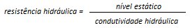 (Equation 4)
The reference relationship between vulnerability and hydraulic resistance is given in Table 1 (VAN STEMPVOORT, EWERT, WASSENAAR, 1992).

Table 1: Vulnerability classes of the AVI method.
Hydraulic Resistance (days) | Vulnerability classes
0-10 | Extremely high
10-100 | High
100-1000 | Moderate

High resistance values indicate that the fluid took a long time to reach the aquifer; therefore its vulnerability is less than in those areas with low resistance values.
In order to classify the vulnerability of the aquifer, the hydraulic conductivity for the wells with information available at SIAGAS was first calculated from Equation 3. As the aim was to determine the vulnerability in the entire area of the city of São Paulo, it was necessary to perform a spatial interpolation of hydraulic conductivity and static level, both by ordinary kriging. These two krigings were performed in the R software, with previously ordered quantile normalization (Peterson and Cavanaugh, 2019), with bestNormalize package, and with semivariograma adjustment by cross-validation with the Automap package (Hiemstra, 2015) in order to reduce the root of the mean squared error. They were later re-transformed to the original scale.
Using the interpolated data, the hydraulic resistance was determined from Equation 3, dividing one raster layer by the other.
The procedures adopted are summarized below:
- Indicative Kriging of well yield with a threshold of 20m³/h;
- Location of contamination points in the municipality;
- Establishment of contamination radius (buffers) around these points;
- Establishment of intersections: with points whose radius reaches water bodies or wells;
- Characterization of intersected water bodies or wells as potentially contaminated;
- Determination and interpolation of the hydraulic conductivity of the wells;
- Interpolation of the static level of the wells to estimate the depth of the water table;
- Calculation of hydraulic resistance;
- Topological analysis of potentially contaminated rivers, demonstrating the accumulation of pollution on the hydrography;
- Calculation of demographic density from the attributes of population and area.

RESULTS AND DISCUSSION
The databases with the results of this study are available at: https://app.box.com/s/1bkyzq50qyessntk915v4doxhn9npdn8.
The semivariograms used for spatial interpolation by kriging, with their respective parameters, are presented in Figures 2 to 4. The range of the semivariogram for the stabilization flow is much shorter than for the static level and for hydraulic conductivity. All three semivariograms showed a high nugget effect in relation to the threshold semivariance, indicating a great variation in close points, which led to the need for a smoothed interpolation surface (MONTÉS, 1994). Figure 5 shows the map of ordinary kriging with static yield data from wells in the study region to determine the radius of the safety area of each contamination point. The standard deviation of this interpolation is shown in Figure 6.
ram of stabilization yield.
Figure 2: Semivariogram of stabilization yield
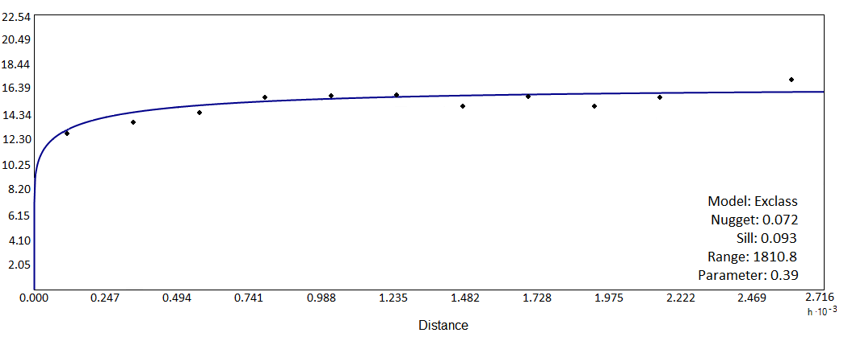
* Where “Exclass” is the abbreviation for Exponential Class / Stable.
Figure 3: Semivariogram of the static level
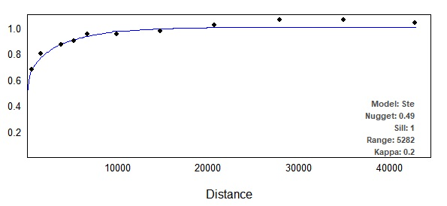
* Where “Ste” is the abbreviation for Matern, M. Stein's parameterization.
Figure 4: Semivariogram of hydraulic conductivity
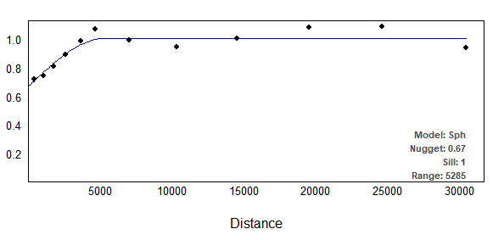
* Where “Sph” is the abbreviation for spherical.
Figure 5: Indicative Kriging indicating the probability that the stabilization yield is above 20m³/h
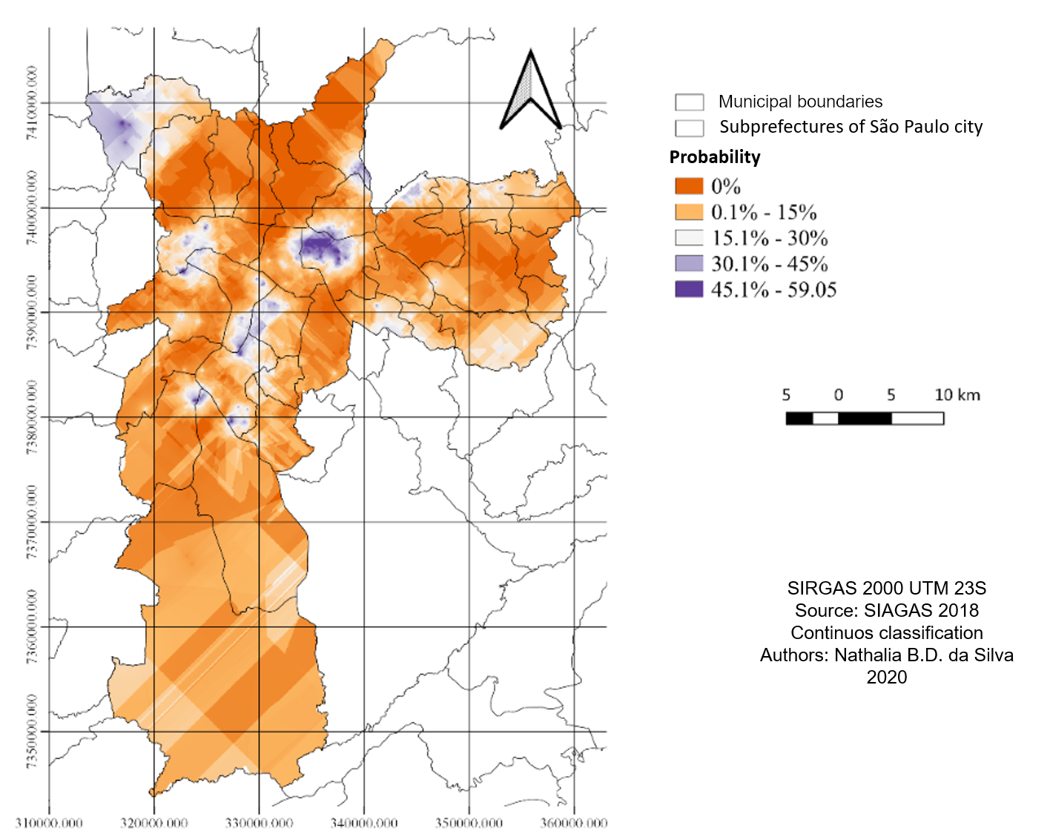
Source: the authors (2020)
Subprefectures such as Capela do Socorro, Mooca, M'Boi Mirim, Perus, and Santo Amaro are more likely to have a static flow above 20m³/h; while subprefectures such as Casa Verde, Cachoeirinha, Freguesia/Brasilândia, Itaquera, Jaçanã/Tremembé, Penha, Pirituba/Jaraguá, and Santana/Tucuruvi present zero probability of finding wells with flow rates above 20m³/h in most of the subprefecture areas. It is in these areas that the safety radius is the smallest—30m.
Figure 6: Standard deviation of indicative kriging of stabilization yield above 20m³/h
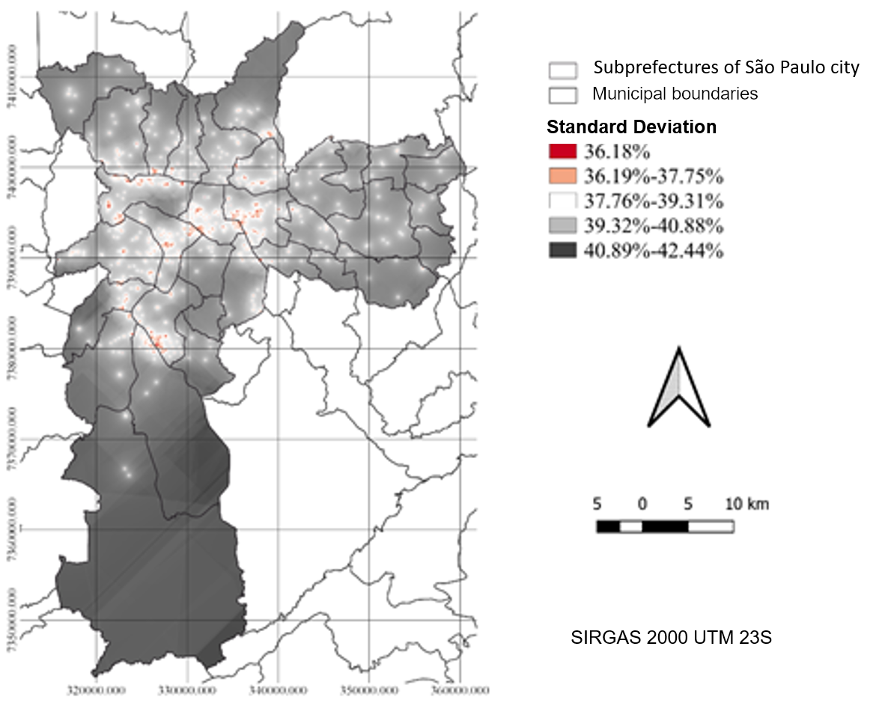
The minimum standard deviation of the interpolation is 36.18%, because very close wells may have very different characteristics. It is worth noting that interpolation is more accurate only where there is greater availability of information (Lloyd and Atkinson, 2001). The southernmost region of the municipality does not have many registered wells and therefore it has less interpolation accuracy.
Figure 7 shows the intersection of the safety radius of contaminated areas with the wells. It can be seen that the wells are concentrated in the central region of the Municipality of São Paulo, in the subprefectures Aricanduva/Formosa/Carrão, Butantã, Campo Limpo, Casa Verde/Cachoeirinha, Freguesia/Brasilândia, Ipiranga, Jabaquara, Lapa, Mooca, Penha, Pinheiros, Pirituba/Jaraguá, Santana/Tucuruvi, Santo Amaro, Sé, Vila Mariana, Vila Maria/Vila Guilherme and Vila Prudente, all with high concentration of wells.
The contaminated areas also follow this pattern of distribution further to the center of the municipality, and are concentrated in the subprefectures Butantã, Casa Verde/Cachoeirinha, Ipiranga, Lapa, Mooca, Pinheiros, Santana/Tucuruvi, Santo Amaro, Sé, Vila Mariana, and Vila Maria/Vila Guilherme. These are areas, historically adjacent to train stations, from which industrial districts developed during the 20th century (STEFANI, 2007).
Wells at risk of contamination are more widely spaced, but still predominate in the central region, being found in the subprefectures Aricanduva/Formosa/Carrão, Capela do Socorro, Casa Verde/Cachoeirinha, Ermelino Matarazzo, Freguesia-Brasilândia, Ipiranga, Lapa, M'Boi Mirim, Mooca, Penha, Pinheiros, Pirituba/Jaraguá, Santo Amaro, São Miguel, Sé, Vila Mariana, Vila Maria/Vila Guilherme and Vila Prudente. As they predominate in the central area, where there was less standard deviation of kriging (Figure 6), there is a greater reliability of the interpolation parameters.

Figure 7: Map of wells at risk of contamination
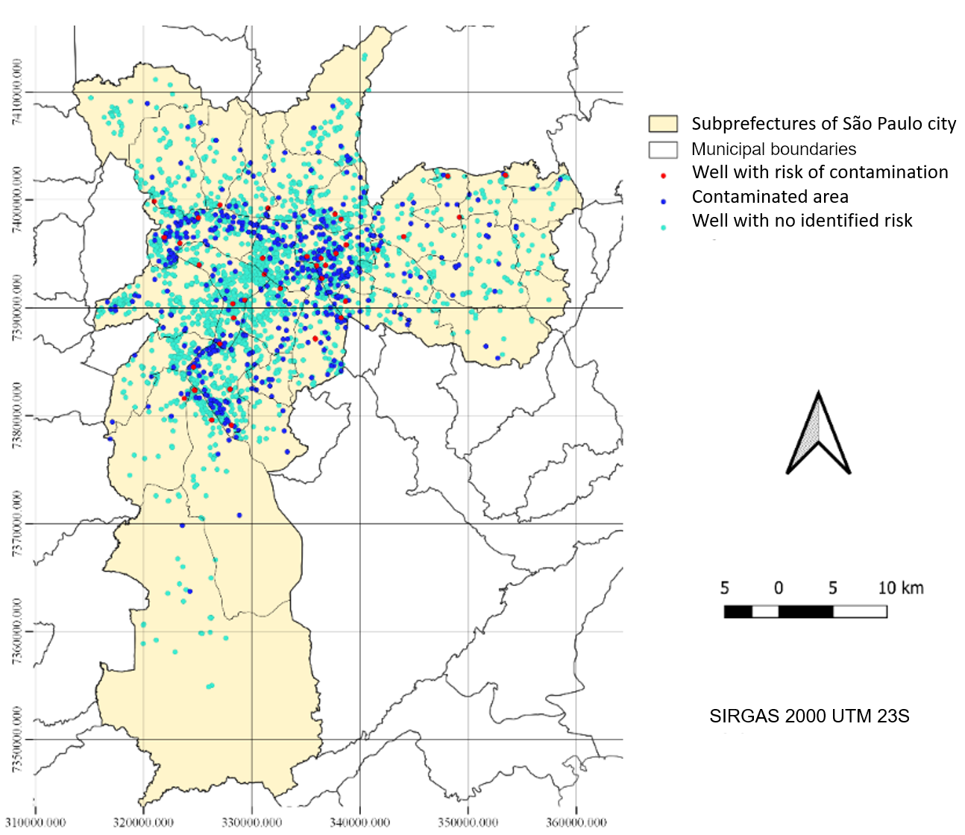

The number of wells at risk of contamination identified is 49, which represents 1.68% of the wells in the Municipality of São Paulo. 65.31% of wells in risk areas are characterized as supply wells. This means that there are 32 wells used for urban, domestic or industrial supply with a risk of being contaminated and represents 1.61% of all wells classified as supply. This risk may be even greater because several wells in the municipality have deficiencies in constructive technical quality, such as lack of cementation, protection slab, and tampion (PACHECO, 1984).
The places where there is a greater risk of contamination of wells were the subprefectures of Aricanduva/Formosa/Carrão, Capela do Socorro, Casa Verde/Cachoeirinha, Ermelino Matarazzo, Freguesia/Brasilândia, Ipiranga, Lapa, M'Boi Mirim, Mooca, Penha, Pinheiros, Pirituba/Jaraguá, Santo Amaro, São Miguel, Sé, Vila Mariana, Vila Maria/Vila Guilherme and Vila Prudente. The supply wells are in Pirituba/Jaraguá, Freguesia/Brasilândia, Vila Maria/Vila Guilherme, Lapa, Sé, Pinheiros, Ipiranga, Santo Amaro, M'Boi Mirim, Capela do Socorro, Ermelino Matarazzo, Mooca, Aricanduva/Formosa/Carrão and Vila Prudente.
Figure 8 shows the intersection of the safety radius of contaminated areas with water bodies.
Figure 8: Map of accumulation of contamination risk points in drainage and dams
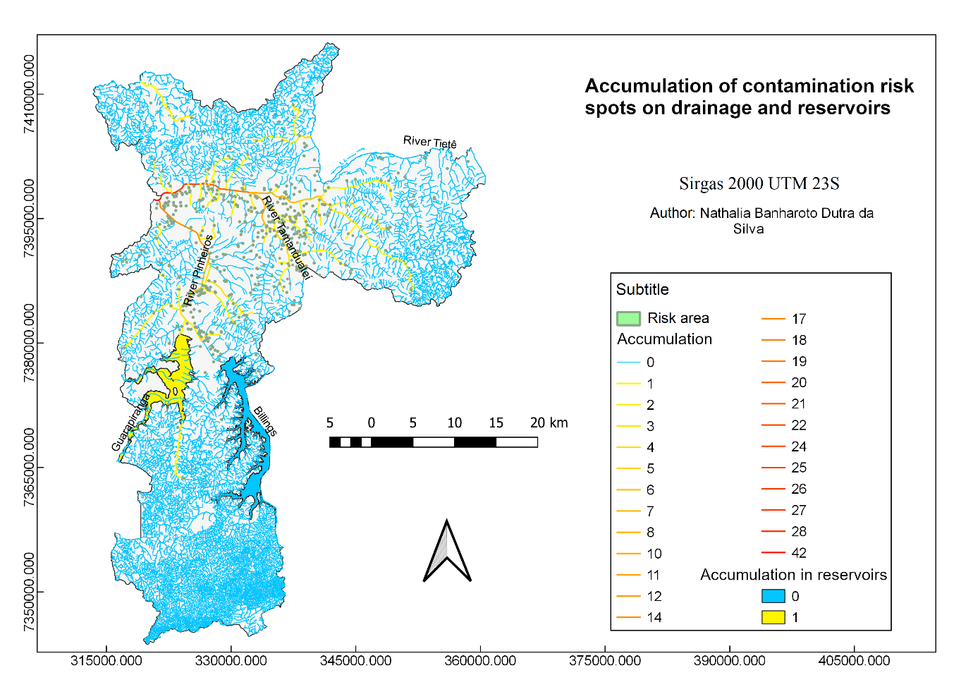
In total, 55 points of intersection of contaminated areas with water courses were identified in the Municipality of São Paulo. The Tietê River has the highest accumulation of upstream risk points, reaching 42 points of risk of contamination at its maximum. This is also because the Tamanduateí and Pinheiros rivers (both with the highest accumulation of risk points) flow into the Tietê River. It should be noted that in addition to the contaminated areas assessed in this article, the Tietê River, in its stretch through the Municipality of São Paulo, also has high contamination of nitrates from leaking septic tanks, according to the study by Varnier and Hirata (2000).
The contaminated rivers and wells have a direct relationship with the development of the municipality. It has been mainly on the banks of the Tietê, Tamanduateí and Pinheiros rivers that the rise of São Paulo took place and the development in this area brought consequences such as the contamination of soil and rivers. It is clear that where there were more anthropic actions, there are now more risk points.
Figure 9 shows the standard error of the result of ordinary kriging. It is observed that the standard error was around 0.80 and 1, and the static level kriging has a larger area with less error, because this parameter had more data compared to the hydraulic conductivity. This is due to the fact that there are fewer wells in SIAGAS with information on pipe diameter, which is necessary for the estimation of hydraulic conductivity.
Figure 9: Standard error of ordinary kriging of static level and hydraulic conductivity
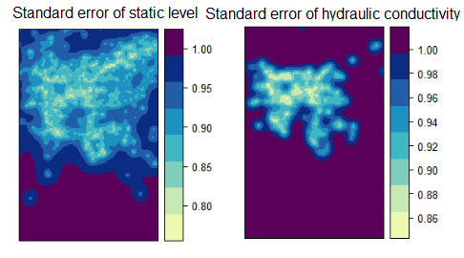
Performing raster division algebra, the hydraulic resistance map is obtained and consequently the AVI (Figure 10). The hydraulic resistance values are very low, and this indicates that there is a predominance of the “Extremely High” vulnerability class (Table 1), which extends throughout the municipality. Only a few small areas in the subprefectures of Lapa, Ipiranga, Vila Prudente, and Aricanduva have comparatively greater hydraulic resistance than the others, but they are still within the “Extremely High” vulnerability class. These conditions of contamination and vulnerability demonstrate that the water resources may be threatened due to the current urban land use, and clearly indicate the need for monitoring, remediation, and recovery of these areas.
These results contrast with the study of Conicelli (2014), which identified the São Paulo aquifer to be of low vulnerability class by the GOD method (FOSTER et al., 2006). The GOD method uses aquifer depth data inputs, in a similar way to the present study, but uses weights referring to lithological characteristics and aquifer confinement. However, the AVI methodology uses hydraulic conductivity data. Furthermore, the definitions of the vulnerability classes for each method are not necessarily compatible with each other. Additionally, the study of Conicelli (2014) was directed to a wider study region (Alto-Tietê Basin), in which the GOD method provided values for each aquifer unit; whereas the present article presents a more detailed mapping of the São Paulo aquifer, including intra-aquifer spatial differentiation.
Figure 10: Map of hydraulic resistance of the aquifer and points of contamination near wells and water bodies in the Municipality of São Paulo
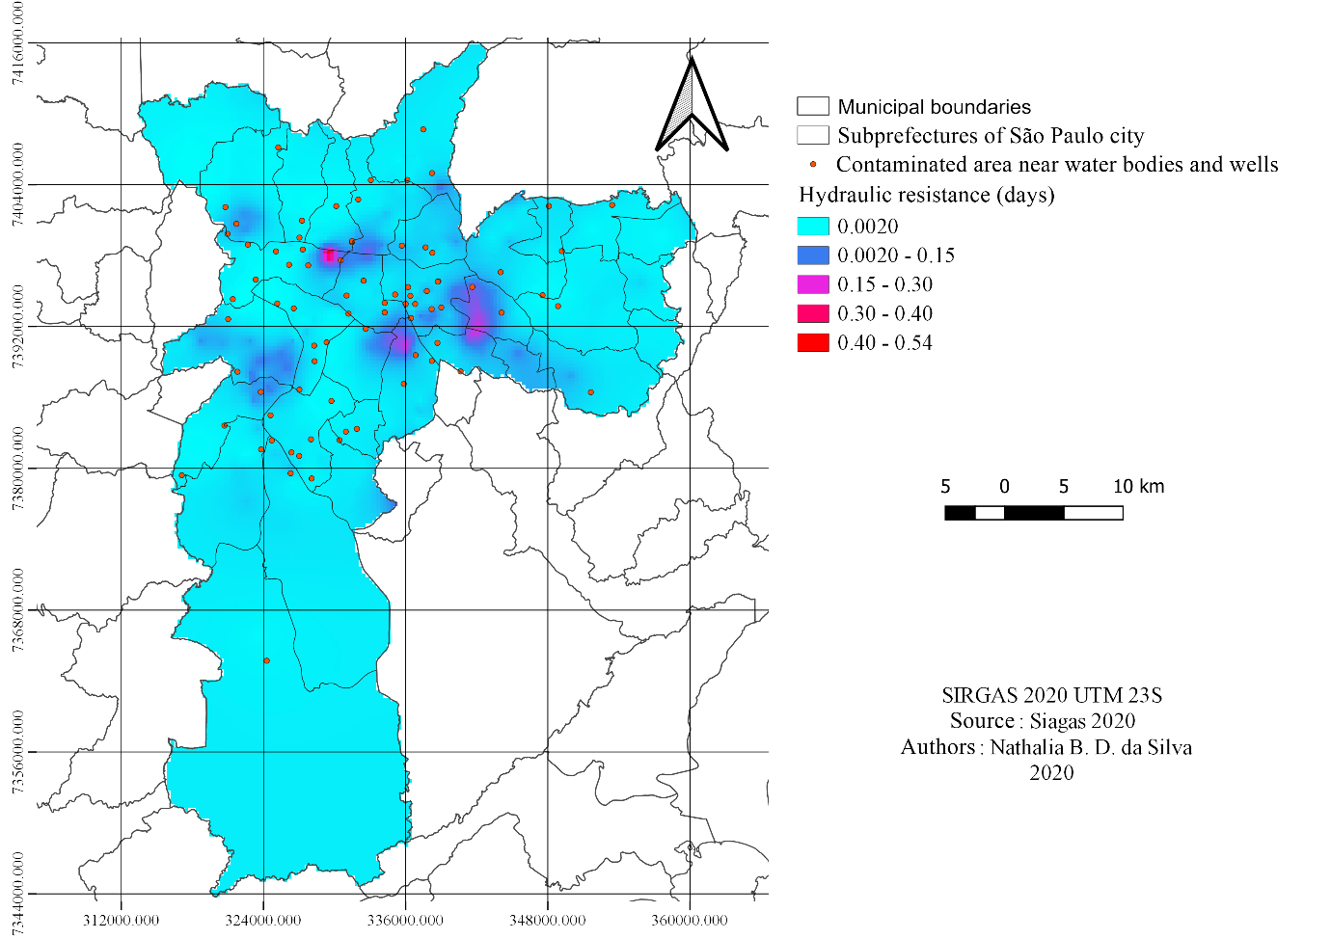
The result of the demographic density is in Figure 11, including the points of contamination. It is clear that the areas with the highest concentration of contaminated areas and wells at risk of contamination also coincide spatially with the areas of greatest demographic density, as they are the result of human activities and their respective needs. It is noteworthy that subprefectures such as Sé, Campo Limpo, Itaim Paulista, Guaianases, Vila Prudente, and Sapopemba are highly densely populated. According to IBGE (2010) data, the subprefectures with the largest number of inhabitants are Campo Limpo, M'Boi Mirim, Capela do Socorro, Itaquera and Penha, all with more than 500 thousand inhabitants.

Figure 11: Map of demographic density and points of contamination near wells and water bodies in the Municipality of São Paulo
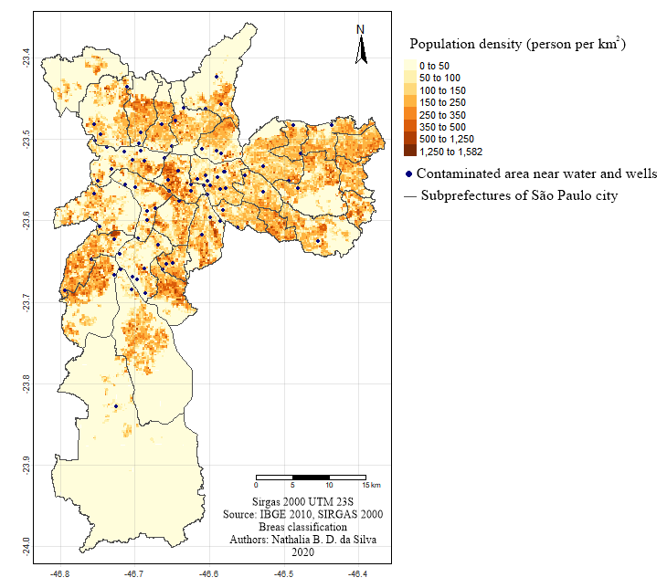
The areas in which there is a coincidence of contamination points, greater demographic density and where there are more intersections with water bodies, are around the Tietê, Tamanduateí and Pinheiros rivers. With regard to the possibility of spreading contaminants, these places should be prioritized for remediation of contaminated areas.

Study limitations and recommendations
The adopted methodology has clear limitations and simplifications. For example, the total extent of each contaminated area was not taken into account, since the base provided by CETESB includes only the central point. In this respect, there may be variations in the stabilization yield within the same contaminated area, influencing the establishment of the protection radius. Also, the buffer created would be expanded if it started from the edge of the perimeters of the contaminated areas, if this information were to be made available in a georeferenced manner by CETESB, instead of being delimited from the central point. In addition, specific factors (such as topography, soil type, type and quantity of the contaminant), which might enhance the spread of contaminants, were not analyzed. Despite these limitations, this method serves as a first indication to prioritize potential sources of contamination and leads to more detailed studies.
For future studies, it would be possible to incorporate new variables into the kriging methods through cokriging and regression-kriging techniques, which allow the use of auxiliary variables. In addition to the spatial layers generated by kriging (such as the AVI), it would also be possible to use a multicriterial weighting approach to combine other information into a single risk indicator, integrating other relevant environmental variables, demographic density (risk exposure), and the density of contaminated areas near water sources.
Furthermore, it is noted that the databases of contaminated areas and wells locate only the information that is officially registered. There may be several other unregistered wells and contaminated areas, leading to additional unmapped contamination risks. Nevertheless, considering the specific databases as samples of a larger universe, it is likely that the remaining unregistered points will be distributed with a similar spatial pattern, concentrating on the subprefectures already identified as priorities. As a directive for public policies, greater coverage and registration of wells and contaminated areas could bring greater reliability to the interpolation methods and, consequently, to the assessment of the risks of water contamination.
The methodology developed in this study can be replicated in other regions, provided that they have information about wells, water bodies and contaminated areas. The CETESB database of contaminated areas covers the entire State of São Paulo, and the IG (2010) orientations for protection radius also cover all of the State's aquifers; thus the methodology could easily be expanded to the state scale. The SIAGAS database covers the entire Brazilian territory, although it might also be possible to use spatial databases of surficial and groundwater permits from state and federal water resource management agencies.

CONCLUSIONS
Analyzing the intersections between points of contamination, wells, and water bodies, in addition to considering the aquifer vulnerability and the exposure of the population to contamination, it was possible to determine points that present greater risk potential for human health and which therefore need to be prioritized. The central region of the Municipality of São Paulo, especially in the subprefectures of Mooca, Sé and Lapa, presented a greater number of contaminated areas close to wells and water courses, with a very high vulnerability to aquifer contamination and high exposure due to the high population concentration.
With regard to the potential spreading of contaminants, the places to be prioritized for remediation of contaminated areas should be those where there is a greater risk of contamination from wells and areas where there are more intersections with water bodies (such as around the Tietê, Tamanduateí, and Pinheiros rivers). Of the 518 points of contamination, 81 are close to wells and water bodies and therefore should be prioritized, especially in the case of wells used as drinking water sources.
The results of this study can be useful both for environmental agencies in public policies of water management and remediation of contaminated areas, and for users of water resources, including residents of those regions at risk. In addition, the results may be important for companies that wish to implement undertakings nearby, for risk assessments by security companies, and to determine whether it is safe or not to collect water resources from wells, rivers, and groundwater.

REFERENCES
ABGE – ASSOCIAÇÃO BRASILEIRA DE GEOLOGIA DE ENGENHARIA. Ensaios de Permeabilidade em Solos: orientações para a sua execução em campo. 1996.
AHMADI, S.H., SEGHAMIZ, A. Application and evaluation of kriging and cokriging methods on groundwater depth mapping. Environ Monit Assess, v. 138, 2008, pp. 357–368
ANA – Agência Nacional de Águas. Panorama da qualidade das águas subterrâneas no Brasil. Brasília. ANA, 2007.
BRILHANTE, O.M.; CALDAS, L.Q.A. Gestão e avaliação de risco em saúde ambiental. Rio de Janeiro: Editora FIOCRUZ, 1999.
CABRAL, J. J. S. P. O movimento das águas subterrâneas. Em: Feitosa, F. A. C et al. (ed.) Hidrogeologia: conceitos e aplicações. 2ª ed. Rio de Janeiro: CPRM. 2008, pp. 77-94.
CAMARGO, E.C.G. Geoestatística: fundamentos e aplicações. In CÂMARA, G., MEDEIROS, J. S. (eds.) Geoprocessamento para projetos ambientais. São José dos Campos: INPE, 1998.
CAMARGO, E.C.G., FUCKS, S.D., CÂMARA, G. Análise espacial de superfícies. In DRUCK, S.; CARVALHO, M.S.; CÂMARA, G.; MONTEIRO, A.V.M. (eds) "Análise Espacial de Dados Geográficos". Brasília, EMBRAPA, 2004 (ISBN: 85-7383-260-6)., pp.79-122.
CETSB, GTZ. Manual de gerenciamento de áreas contaminadas. 2.ed. São Paulo: CETESB, 2001.
CETESB. Ficha de Informação Toxicológica (FIT). Divisão de Toxicologia, Genotoxicidade e Microbiologia Ambiental, 2020. Disponível em: < https://cetesb.sp.gov.br/laboratorios/servicos/informacoes-toxicologicas/>. Acessado em 6 de julho de 2020.
CETESB. Relação de Áreas Contaminadas e Reabilitadas no Estado de São Paulo. 2019. Disponível em <https://cetesb.sp.gov.br/areas-contaminadas/relacao-de-areas-contaminadas/> Acessado 6 de Julho de 2020.
CONICELLI, B.P. Gestão das águas subterrâneas na Bacia Hidrográfica do Alto Tietê (SP). São Paulo: Tese (Doutorado)-Universidade de São Paulo. Programa de Pós-Graduação emem Recursos Minerais e Hidrogeologia. 2014
DRUCK, S.; CARVALHO, M.S.; CÂMARA, G.; MONTEIRO, A.V.M. (eds) "Análise Espacial de Dados Geográficos". Brasília, EMBRAPA, 2004 (ISBN: 85-7383-260-6).
DYMINSKI, A. S. “Contaminação de solos e águas subterrâneas”. UFPR. 2006. Disponível em <http://www.cvs.saude.sp.gov.br/up/Contaminacao%20de%20solos.pdf>. Acesso em 6 de julho de 2020.
FELGUEIRAS, C.A., DRUCK, S., MONTEIRO, A.M.V., 2002. Análise espacial de superfícies: o enfoque da geoestatística por indicação. Em: DRUCK, S.; CARVALHO, M.S.; CÂMARA, G.; MONTEIRO, A.V.M. (eds) "Análise Espacial de Dados Geográficos". Brasília, EMBRAPA, 2004 (ISBN: 85-7383-260-6).
FETTER, C.W. Contaminant hidrogeology. New York: Macmillan Publishing Company, 1993.
GOVERNO DO ESTADO DE SÃO PAULO. Decreto 32955/91 | Decreto nº 32.955, de 7 de fevereiro de 1991. Disponivel em <https://governo-sp.jusbrasil.com.br/legislacao/183184/decreto-32955-91>. Acesso 28 de Agosto de 2019.
GOVERNO DO ESTADO DE SÃO PAULO. Modelo Digital de Elevação do Estado de São Paulo. Disponível em <http://www.cati.sp.gov.br/portal/produtos-e-servicos/publicacoes/acervo-tecnico/modelo-digital-de-elevacao-do-estado-de-sao-paulo>. Acesso em 19 de Julho de 2019.
GUIGUER, N.; KOHNKE, M. W. Métodos para determinação da vulnerabilidade de aquíferos. XII Congresso Brasileiro de Águas Subterrâneas, 2002, p.4-5
GUNDOGDU, K.S., GUNEY, I., Spatial analyses of groundwater levels using universal kriging. Journal of earth system science, v. 116, n. 1, 2007, pp.49-55.
HABERMANN, M.; GOUVEIA. Requalificação urbana em áreas contaminadas na cidade de São Paulo. Estudos Avançados, v. 28, n. 82, p. 129-137, 2014.IBGE. Área territorial brasileira. Rio de Janeiro: IBGE, 2018.
HIEMSTRA, P. Package ‘automap’. CRAN. 2015. Disponível em: https://cran.r-project.org/web/packages/automap/automap.pdf. Acessado em 6 de julho de 2020.
INSTITUTO BRASILEIRO DE GEOGRAFIA E ESTATÍSTICA - IBGE. Área territorial brasileira. Rio de Janeiro: IBGE, 2018.
INSTITUTO BRASILEIRO DE GEOGRAFIA E ESTATÍSTICA - IBGE Diretoria de Pesquisas, Coordenação de População e Indicadores Sociais, Estimativas da população residente com data de referência 1° de julho de 2019, Rio de Janeiro: IBGE, 2019.
INSTITUTO BRASILEIRO DE GEOGRAFIA E ESTATÍSTICA - IBGE. Grade Estatística. Rio de Janeiro: IBGE, 2016. Disponível em: <ftp://geoftp.ibge.gov.br/recortes_para_fins_estatisticos/grade_estatistica/censo_2010/grade_estatistica.pdf>. Acessado em 6 de julho de 2020.
INSTITUTO BRASILEIRO DE GEOGRAFIA E ESTATÍSTICA - IBGE. Censo Demográfico 2010. Disponível em: <https://censo2010.ibge.gov.br/>. Acesso em 6 de julho de 2020.
INSTITUTO BRASILEIRO DE GEOGRAFIA E ESTATÍSTICA - IBGE. Malhas Digitais < http://mapas.ibge.gov.br/bases-e-referenciais/bases-cartograficas/malhas
-digitais.html > Acesso em 17 de abril de 2019.
INSTITUTO GEOLÓGICO - IG. Roteiro orientativo para delimitação de área de proteção de poços. Cadernos do Projeto Ambiental Estratégico Aquíferos. Secretaria do Meio Ambiente. São Paulo, 2010.
JOHNSTON, K., KRIVORUCHKO, K., LUCAS, N., VER HOEF, J. M. (2001). Using ArcGIS geostatistical analyst. Redlands: Esri.
LLOYD, C.D., ATKINSON, P.M. Assessing uncertainty in estimates with ordinary and indicator kriging. Computers & Geosciences, v. 27, n. 8, 2001, pp.929-937.
MMA – SRHU. Ministério do meio Ambiente – Secretaria de Recursos Hídricos e Ambiente Urbano. Águas Subterrâneas, um recuso conhecido a ser protegido. Brasília, 2007.
MOSLEMZADEH, M., SALARIZAZI, M., SOLEYMANI, S. Application and assessment of kriging and cokriging methods on groundwater level estimation. J Am Sci, v. 7, n. 7, 2011, pp. 34–39
MONTÉS, P., Smoothing noisy data by kriging with nugget effects. In: Laurent, PJ, Le Méhauté, A., et al., eds. Wavelets, Images and Surface Fitting, 1994, pp.371-378.
NAKANO, V.; AVILA-CAMPOS, M.J. DEPARTAMENTO DE MICROBIOLOGIA – UNIVERSIDADE DE SÃO PAULO. Metais Pesados: Um Perigo Eminente. Disponível em <http://www.icb.usp.br/bmm/mariojac/index.php?option=com_content&view=article&id=33&Itemid=56&lang=br>. Acesso 29 de junho de 2020.
OLIVER, M.A., WEBSTER, R., Basic steps in geostatistics: the variogram and kriging. New York, NY: Springer International Publishing, 2015.
PACHECO, A. Análise das características técnicas e da legislação para uso e proteção das águas subterrâneas em meio urbano (município de São Paulo) (Doctoral dissertation, Universidade de São Paulo), 1984.
PETERSON, R.A., CAVANAUGH, J.E. Ordered quantile normalization: a semiparametric transformation built for the cross-validation era. Journal of Applied Statistics, 2019, pp.1-16.
PREFEITURA DO MUNICÍPIO DE SÃO PAULO. GEOSAMPA. Disponivel em <geosampa.prefeitura.sp.gov.br/ PaginasPublicas/_SBC.aspx> Acessado em 28 de Novembro de 2018.
RICCOMINI, C.; COIMBRA, A. M. Geologia da Bacia Sedimentar de São Paulo. In: FERREIRA, A. A.; ALONSO, U. R.; LUZ, P. L. (Ed.). Solos da Cidade de São Paulo. São Paulo: ABMS/ ABEF, 1992. p. 37-94.
ROCHA, G., FERNANDES, A.J., MANCUSO, M.A., CAMPOS, J.E., TAKAHASHI, A.T., ODA, G.H., PERROTTA,.M., SALVADOR, E.D.,et al. Mapa de águas subterrâneas do Estado de São Paulo. Revista Águas Subterrâneas, Anais do XIV Congresso Brasileiro de Águas Subterrâneas, 2006.
SANTOS, E., UNGARI, H. C. N., SANTOS, M. B. Principais técnicas de remediação e gerenciamento de áreas contaminadas por hidrocarbonetos no Estado de São Paulo. Unicamp: UNICAMP. 2008. Disponível em: <https://cetesb.sp.gov.br/escolasuperior/wp-content/uploads/sites/30/2016/06/Edson_Helio_Matilde.pdf>. Acessado em 6 de julho de 2020.
SERVIÇO GEOLÓGICO - CPRM. Sistema de Informações de Águas Subterrâneas - SIAGAS. Disponível em < http://siagasweb.cprm.gov.br/layout/index.php >. Acesso em 10 de Dezembro de 2018.
SOUZA, N.A. de. Vulnerabilidade à poluição das águas subterrâneas: um estudo do Aquífero Bauru na zona urbana de Araguari, MG. 2009. 9p. Dissertação (Mestrado) - Universidade Federal de Uberlândia, Uberlândia. Disponível em <repositorio.ufu.br/handle/123456789/14133>. Acesso 29 de Agosto de 2019.
STEFANI, C.R.B. O sistema ferroviário paulista: um estudo sobre a evolução do transporte de passageiros sobre trilhos (Doctoral dissertation, Universidade de São Paulo), 2007.
VAN STEMPVOORT, D.; EWERT, L.; WASSENAAR, L. AVI: A Method for Groundwater Protection Mapping in the Prairie Provinces of Canada. PPWD pilot project, Sept. 1991 - March 1992. Groundwater and Contaminants Project, Environmental Sciences Division, National Hydrology Research Institute, Saskatoon, 1992.
VARNIER, C., HIRATA, R. Contaminação da água subterrânea por nitrato no parque ecológico do Tietê-São Paulo, Brasil. Revista Águas Subterrâneas. Annals of the 1st joint congress of groundwater. 2000.
VASCONCELOS, V.V., KOONTANAKULVONG, S., SUTHIDHUMMAJIT, C., MARTINS JUNIOR, P.P. and HADAD, R.M. Analysis of spatial–temporal patterns of water table change as a tool for conjunctive water management in the Upper Central Plain of the Chao Phraya River Basin, Thailand. Applied Water Science, v. 7, n. 1, 2017, pp.245-262.
YAMAMOTO, J. K.; LANDIM, P. M. B. Geoestatística: Conceitos e Aplicações. 2. ed. São Paulo: Oficina de Textos, 2013. 214p

Available at < cetesb.sp.gov.br/areas-contaminadas/>, accessed 13 July 2020.
Available at http://siagasweb.cprm.gov.br/layout/, accessed 10 December 2018.

